Record No: 0668
HEATHER EDITH BAKER (Heather)
of 42, Squitchey Lane, Oxford
2nd dau of Col. Cecil Norris Baker(0669) CIE Indian Army by his wife Ella Mary (nee Hutchinson)

Birth: 9 Apr 1905
Marriage: 7 Sept 1925 at St Nicholas’ Church, Longparish, Hants to Gualter H R B Somerville
M.C.(0667) (Pat)
Death: ? March 1994, in Oxford. Bd St Mary the Virgin Churchyard, Adderbury.

Source: Somerville Index

Notes:

Mother of:

Patricia May Naomi Somerville (0685) bn 2 May 1929
Julia Heather Margaret Somerville (0687) bn 27 October 1931

Further research:

Engagement announcement:
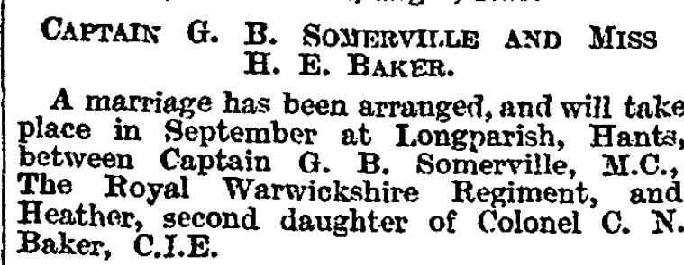
The Times, 12 Aug 1925

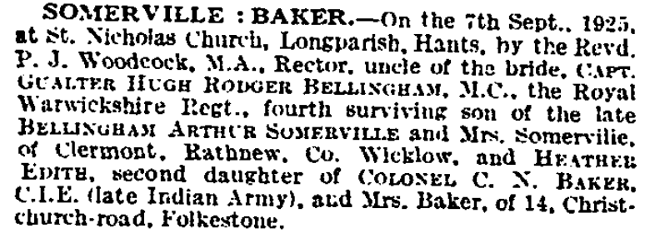
The Times, 11 Sept 1925

NB. Pat was 4th son but 3rd surviving son, Alan having died in 1887.

Letter from Heather Baker to Merlie Truell, franked 1925 on the envelope. This may have been in response to a letter from Merlie to her/Pat following their engagement which had been announced a week earlier.

The Curacy
Longparish
Whitchurch
Aug 19th

Dearest Merlie,

Many happy returns of your birthday; I am afraid I am rather behind the times, but as they say “Better late than never,” but “Better never late.”! However I hope you will forgive me. Uncle Paddy is going up to London tomorrow and he is going to see if he can find a little present for you from us both, as there are no shops here in the village in which we could find you something.

It is getting very near now to you all coming over here, & when one is busy time passes so quickly.

With best love, & every good wish for many happy birthdays to come.

From your loving

Nauntie

Clermont
Rathnew
Co Wicklow
31 May 1927

My dear Merie

Well! - & how’s life on the old farm, or I suppose it would be more correct to say “at the old school”! – I hope you are a good little girl & are having your lessons as a good little girl should, + how I always did when I was at school (except of course when I didn’t)!

Uncle Pat + I have played a lot of Golf since you came and caddied for us, + we have been much more successful, and have only lost one game out of many – And we have been out to one or two tennis parties + & have also played here two or three times.

How’s the cake-making getting on? I hope that you & Ray will be very good at them, by the time Uncle Pat & I come to stay, that is of course if your mother can put us up! Then I will show you how I can make a cake, which will probably give you violent indigestion for weeks afterwards!

Uncle Pat and I are going down to stay at Longparish for about six weeks from the 28th of July, which is quite near the New Forest, so perhaps we shall be able to come + see you when you are in Camp and New Milton – or will you not be allowed to see any visitors?

Tea is nearly ready, and I am very hungry – so I will end this dull miserable epistle, by sending 1 ton of love to your Mother and Father, 1cwt to Ray, 1 lb to Michael, 1 oz to Toby, 1 gramme to GeoRge, and to you last but not least my love as many milligrammes as you would like to take but you might like to let me know by return of post how much you do like so that I shall know how low my store is getting!

Ever the affectionate Aunt Heather

After Pat’s death, Heather acted as Warden of St Anne’s House in Bradmore Road, Oxford, the students’ residence for St
Anne’s College

WBRBS remembers Heather in her later years at Squitchey Lane in Oxford, kind and thoughtful to all her visitors and devoted to her family. A very strong personality.

